OLA ANALYSIS
1. Retrieve all successful bookings:
SELECT * FROM ola.bookings WHERE Booking_Status = 'Success';
Output: 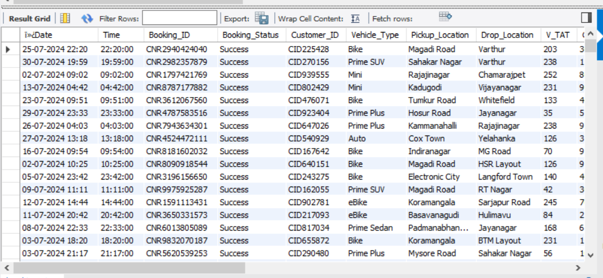

2. Find the average ride distance for each vehicle type:
SELECT Vehicle_Type, AVG(Ride_Distance) as avg_distance FROM ola.bookings GROUP BY Vehicle_Type;
Output:
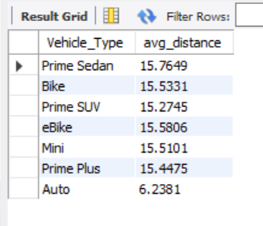

3. Get the total number of cancelled rides by customers:
SELECT COUNT(*) FROM ola.bookings WHERE Booking_Status = 'canceled by Customer';
Output:
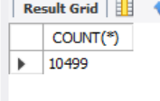

4. List the top 5 customers who booked the highest number of rides:
SELECT Customer_ID, COUNT(Booking_ID) as total_rides FROM ola.bookings GROUP BY Customer_ID ORDER BY total_rides DESC LIMIT 5;
Output:
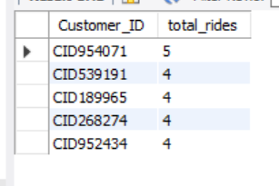
5. Get the number of rides cancelled by drivers due to personal and car-related issues:
SELECT COUNT(*) FROM ola.bookings WHERE canceled_Rides_by_Driver = 'Personal & Car related issue';
Output:
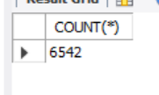

6. Find the maximum and minimum driver ratings for Prime Sedan bookings:
SELECT MAX(Driver_Ratings) as max_rating, MIN(Driver_Ratings) as min_rating FROM ola.bookings WHERE Vehicle_Type = 'Prime Sedan';
Output:
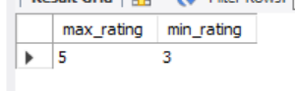
7. Retrieve all rides where payment was made using UPI:
SELECT * FROM ola.bookings WHERE Payment_Method = 'UPI';
Output:
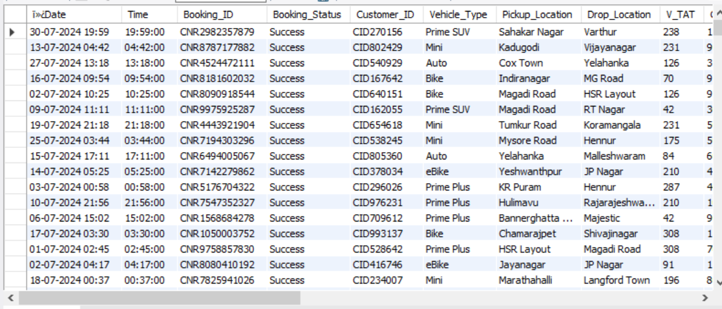

8. Find the average customer rating per vehicle type:
SELECT Vehicle_Type, AVG(Customer_Rating) as avg_customer_rating FROM ola.bookings GROUP BY Vehicle_Type;
Output:
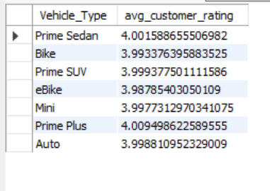
9. Calculate the total booking value of rides completed successfully:
SELECT SUM(Booking_Value) as total_successful_value FROM ola.bookings WHERE Booking_Status = 'Success';
Output:
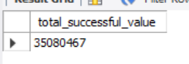

10. List all incomplete rides along with the reason:
SELECT Booking_ID, Incomplete_Rides_Reason FROM ola.bookings WHERE Incomplete_Rides ='Yes';
Output:
